# 5a- Sitemap Practical

**Creating the SiteMapPath Control :** Now lets create an application by using the SiteMapPath control. In this application we design the following three pages:

* The Home Page (**Default.aspx**)
* The First Page (**myweb1.aspx**)
* The Second page (**myweb2.aspx**)

Now we can use the SiteMapPath control using following steps:  
  
**Step 1 :**Open **Microsoft Visual Studio 2010**. **Step 2 :**Select **File->New->Web Site.**

**Step 3 :** Select **ASP.NET Web Site** and name it as **mywebsite**.

**Step 4 :** Add two web forms to the application named **myweb1.aspx** and **myweb2.aspx** by performing the following steps:                 

* Move to the **Solution Explorer** window
* Right-click on the application name and select the **Add New Item** option from the context menu
* Name the web form as **myweb1.aspx** and click the **Add** button

**Step 5 :**Similarly add the **myweb2.aspx** web form to the application. After that we have to add the **Site Map** file into the project. The Site Map file is the XML file and has the extension **.sitemap**. The steps are as follows.

**Step 6 :** Right-click the application in the **Solution Explorer** window and then click the **Add New Item** option from the context menu.  
  
**Step 7 :** Select the **Site** **Map** Template from the Templates Pane. Note that, by default, the file has the name **web.sitemap**.

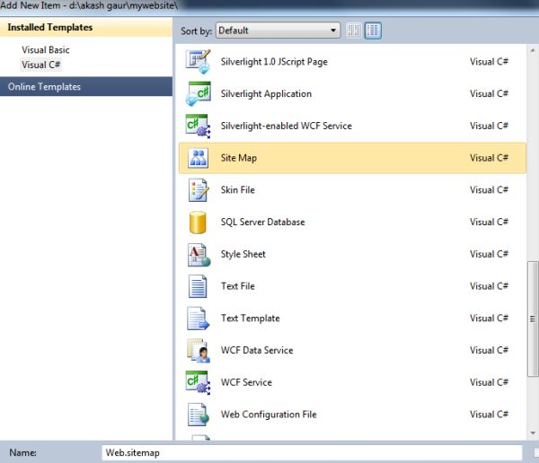

**Step 8 :** Now click the **Add** button to add the sitemap file to our application.

**Step 9 :** Now we can check that the sitemap file has been included in our project and we can see it in the Solution Explorer. And now we have to set the URL and title attributes in the sitemap file.

<?xml version="1.0" encoding="utf-8" ?>  
<siteMap xmlns="http://schemas.microsoft.com/AspNet/SiteMap-File-1.0" >  
        <siteMapNode url="Default.aspx" title="myhomepage"  description="">  
             <siteMapNode url="myweb1.aspx" title="myfirstpage"  description="" />  
             <siteMapNode url="myweb2.aspx" title="mysecondpage"  description="" />  
        </siteMapNode>  
</siteMap>  
    
**Step 10 :** Now Add one **SiteMapPath** control on the **Default.aspx** page from the navigation tab of the toolbox.

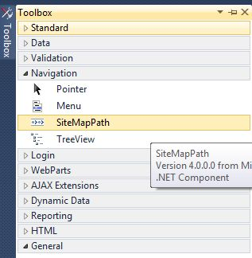

**Step 11 :**Add three labels and two hyperlink controls from the toolbox to the **Default.aspx** page and set the text property of the control.

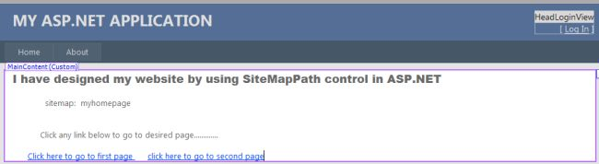

**Step 12 :** Now set the **NavigateUrl** property of the first hyperlink control and select the **myweb1.aspx** file as follows.  
  
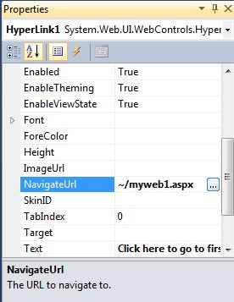

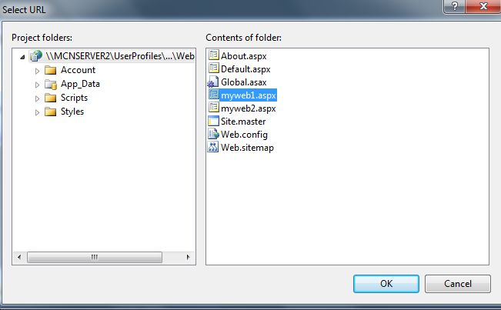  
  
**Step 13**:  Now set the **NavigateUrl** Property of second hyperlink control and select **myweb2.aspx**file.  
  
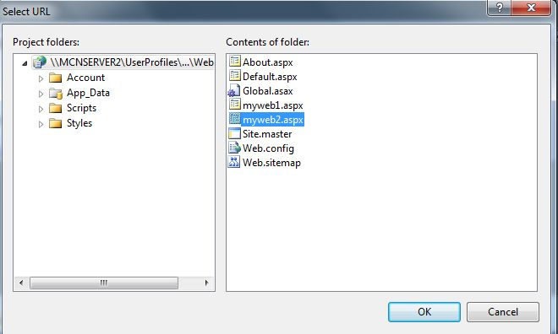  
  
The source code of the **Default.aspx** page is as follows:  
  
<%@ Page Title="Home Page" Language="C#" MasterPageFile="~/Site.master"AutoEventWireup="true"  
    CodeFile="Default.aspx.cs" Inherits="_Default" %>  
<asp:Content ID="HeaderContent" runat="server" ContentPlaceHolderID="HeadContent">  
</asp:Content>  
<asp:Content ID="BodyContent" runat="server" ContentPlaceHolderID="MainContent">  
    <asp:Label ID="Label1" runat="server"   
        Text="I have designed my website by using SiteMapPath control in ASP.NET"   
        Font-Bold="True" Font-Names="Arial Black" Font-Size="Large"></asp:Label>  
    <br />  
    <br />  
    <asp:Label ID="Label2" runat="server" Text="sitemap:"></asp:Label>  
              <asp:SiteMapPath ID="SiteMapPath1" runat="server">  
    </asp:SiteMapPath>  
    <br />  
    <br />  
    <br />  
             <asp:Label ID="Label3" runat="server"   
        Text="Click any link below  to go to desired page............."></asp:Label>  
    <br />  
    <br />    <asp:HyperLink ID="HyperLink1" runat="server" NavigateUrl="~/myweb1.aspx">Click here to go to first page </asp:HyperLink>    <asp:HyperLink ID="HyperLink2" runat="server" NavigateUrl="~/myweb2.aspx">click here to go to second page</asp:HyperLink>  
</asp:Content>  
 **Step 14 :** Now in the design mode of the **myweb1.aspx** page, add the same control but add only one hyperlink control and set its **NavigateUr**l property to **myweb2.aspx** then click ok.

The source code of the **myweb1.aspx** page is as follows:  
  
<%@ Page Language="C#" AutoEventWireup="true" CodeFile="myweb1.aspx.cs"Inherits="myweb1" %>  
<!DOCTYPE html PUBLIC "-//W3C//DTD XHTML 1.0 Transitional//EN""http://www.w3.org/TR/xhtml1/DTD/xhtml1-transitional.dtd">  
<html xmlns="http://www.w3.org/1999/xhtml">  
<head runat="server">  
    <title></title>  
</head>  
<body>  
    <form id="form1" runat="server">  
    <div>        <asp:Label ID="Label1" runat="server" Font-Bold="True" Font-Names="Arial Black"   
            Font-Size="Large"   
            Text="Thank you for clicking.This is My First Webpage.............."></asp:Label>  
        <br />  
        <br />  
                     <asp:Label ID="Label2" runat="server" Text="SiteMap:"></asp:Label>  
               
        <asp:SiteMapPath ID="SiteMapPath1" runat="server">  
        </asp:SiteMapPath>  
        <br />  
        <br />        <asp:HyperLink ID="HyperLink1" runat="server" NavigateUrl="~/myweb2.aspx">click here to go to mywebpage2</asp:HyperLink>  
    </div>  
    </form>  
</body>  
</html>  
  
**Step 15 :**Now in the design mode of the **myweb2.aspx** page, add the same controls as in myweb1.aspx and set the NavigateUrl property of the hyperlink as**Default.aspx**then click ok.

The source code of **myweb2.aspx** is as follows:  
  
<%@ Page Language="C#" AutoEventWireup="true" CodeFile="myweb2.aspx.cs"Inherits="myweb2" %>  
<!DOCTYPE html PUBLIC "-//W3C//DTD XHTML 1.0 Transitional//EN""http://www.w3.org/TR/xhtml1/DTD/xhtml1-transitional.dtd">  
<html xmlns="http://www.w3.org/1999/xhtml">  
<head runat="server">  
    <title></title>  
</head>  
<body>  
      <form id="form1" runat="server">  
      <div>      
            <asp:Label ID="Label1" runat="server" Font-Bold="True" Font-Names="Arial Black"   
                   Font-Size="Large"   
                   Text="Thanx for Clicking.This is my Second webpage by using SiteMapPath control.................">  
            </asp:Label>  
      </div>  
      <p>   
            <asp:Label ID="Label2" runat="server" Text="SiteMap: "></asp:Label>  
                      <asp:SiteMapPath ID="SiteMapPath1" runat="server">  
            </asp:SiteMapPath>  
      </p>  
      <p>&nbsp;</p>  
       
     <asp:HyperLink ID="HyperLink1" runat="server" NavigateUrl="~/Default.aspx">Click here to go to Home page</asp:HyperLink>&nbsp;  
     </p>  
     </form>  
</body>  
</html>  
  
**Step 16**: Now in the Solution Explorer window, right click on the **Default.aspx** page and select the **Set As Start Page** option.

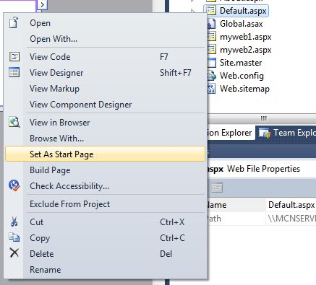  
  
**Step 17:** Press the **F5** key to run the application.

**Output :**

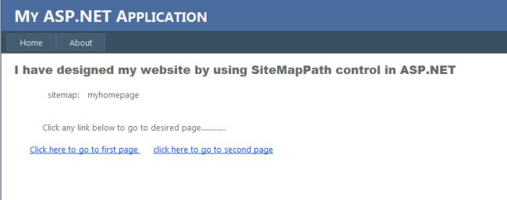

After clicking on the first link the output is as follows.

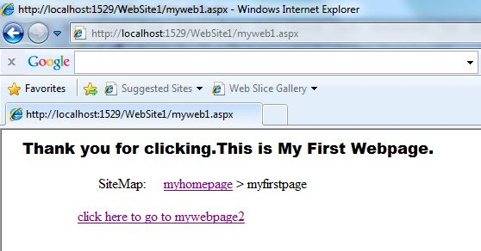

After clicking the link, the output of the second web page is as follows:

